DFA solved examples
Example 1: Draw a DFA for the language accepting strings ending with ‘0’ over input alphabets ∑={0, 1} ?
Solution:
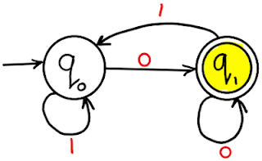

Example 2: Draw a DFA for the language accepting strings ending with ‘01’ over input alphabets ∑={0, 1} ?
Solution:
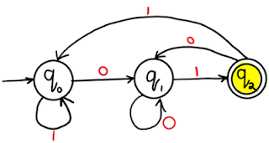

Video lecture DFA ending with ab

Example 3: Draw a DFA for the language accepting strings ending with ‘00’ over input alphabets ∑={0, 1} ?
Solution:
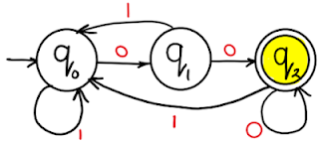

Example 4: Draw a DFA for the language accepting strings ending with ‘011’ over input alphabets ∑ = {0, 1} ?
Solution:
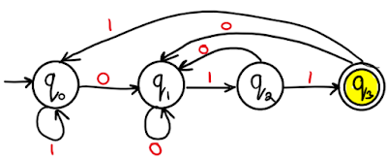

Example 5: Draw a DFA for the language accepting strings ending with ‘0110’ over input alphabets ∑ = {0, 1} ?
Solution:
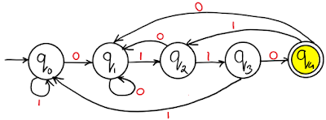
Example 6: Draw a DFA for the language accepting strings ending with ‘0011’ over input alphabets ∑ = {0, 1} ?
Solution:
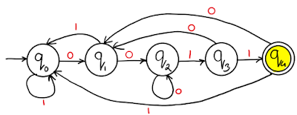
Example 7: Draw a DFA for the language accepting strings with ‘0’ only over input alphabets ∑={0, 1} ?
Solution:
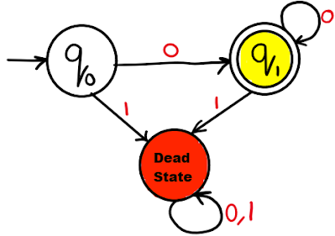
Dead State in DFA

Example 8: Draw a DFA for the language accepting strings with ‘0’ and '1' only over input alphabets ∑={0, 1} ?
Solution:
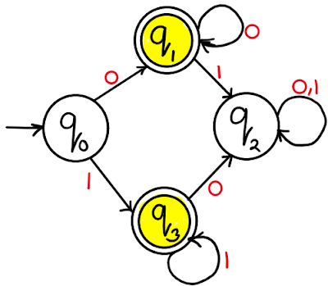
Example 9: Draw a DFA for the language accepting strings starting with ‘0’ over input alphabets ∑={0, 1} ?
Solution:
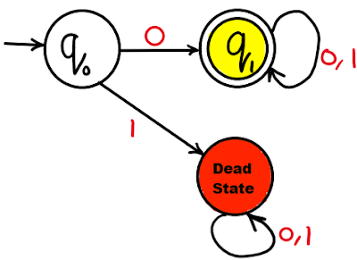
Video lecture on DFA starting with 'a'

Example 10: Draw a DFA for the language accepting strings starting with ‘01’ over input alphabets ∑={0, 1} ?
Solution:
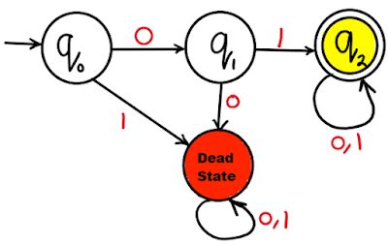
Example 11: Draw a DFA for the language accepting strings starting with ‘00’ over input alphabets ∑={0, 1} ?
Solution:
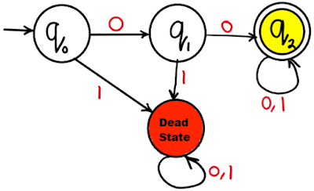
Example 12: Draw a DFA for the language accepting strings starting with ‘011’ over input alphabets ∑ = {0, 1} ?
Solution:
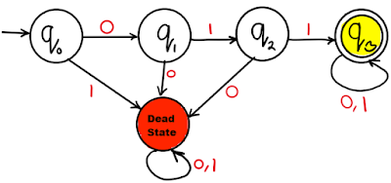
Example 13: Draw a DFA for the language accepting strings starting with ‘0110’ over input alphabets ∑ = {0, 1} ?
Solution:
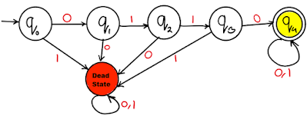
Example 14: Draw a DFA for the language accepting strings starting with ‘0011’ over input alphabets ∑ = {0, 1} ?
Solution:
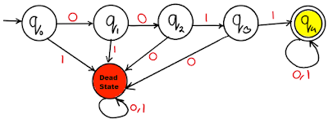
Example 15: Draw a DFA for the language accepting strings starting with ‘00’ or '11' over input alphabets ∑ = {0, 1} ?
Solution:
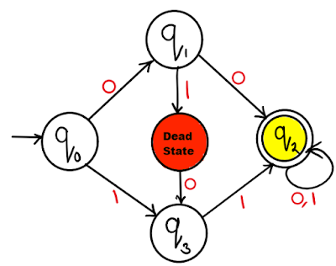

Example 16: Draw a DFA for the language accepting strings without substring ‘00’ over input alphabets ∑ = {0, 1} ?
Solution:
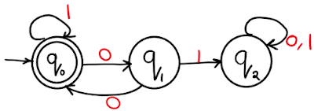
Example 17: Draw a DFA for the language accepting even binary numbers strings over input alphabets ∑ = {0, 1} ?
Soluntion:
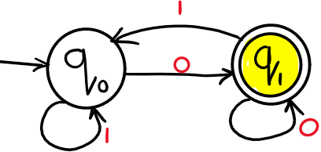
Example 18: Draw a DFA for the language accepting odd binary numbers strings over input alphabets ∑ = {0, 1} ?
Solution:
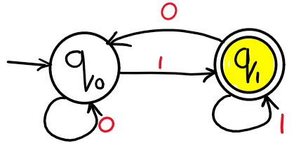
Example 19: Draw a DFA for the language accepting odd or even binary numbers strings over input alphabets ∑ = {0, 1} ?
Solution:
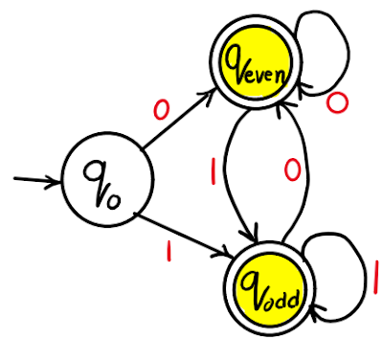
Example 20: Draw a DFA for the language accepting strings containg even number of total zeros over input alphabets ∑ = {0, 1} ?
Solution:
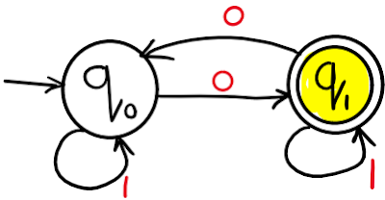
Example 21: Draw a DFA for the language accepting strings starting and ending with different characters over input alphabets ∑ = {0, 1} ?
Soluiton:
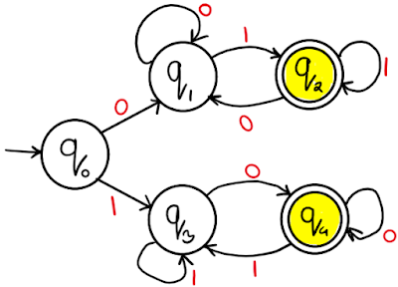
Example 22: Draw a DFA for the language accepting strings starting and ending with same character over input alphabets ∑ = {0, 1} ?
Solution:
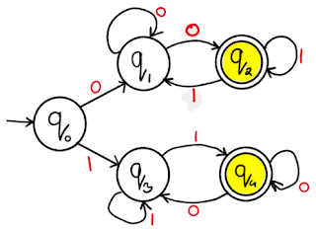

Example 23: Draw a DFA for the language accepting strings starting and ending with '0' always over input alphabets ∑ = {0, 1} ?
Solution:
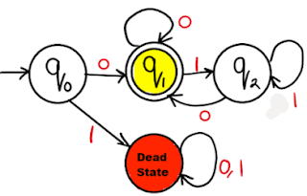

Example 24: Draw a DFA for the language accepting strings containing three consecutives '0' always over input alphabets ∑ = {0, 1} ?
Solution:
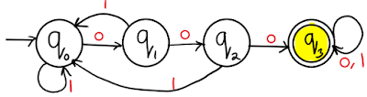

Example 25: Draw a DFA for the language accepting strings such that each '0' is immediately preceded and followed by '1' over input alphabets ∑ = {0, 1} ?
Solution:
